Lab 3 Lap Report

Part A
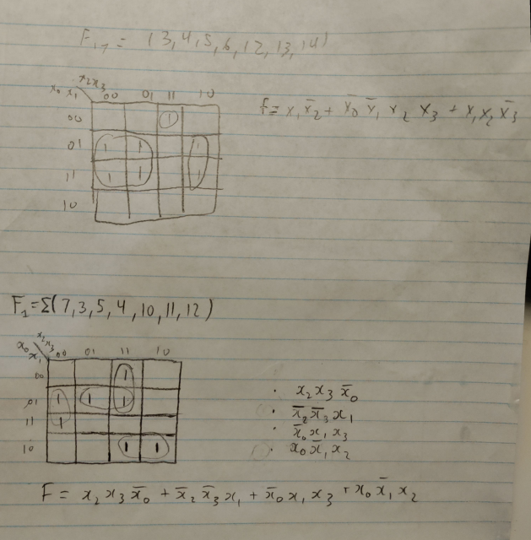
This was how I completed my k-mapping for the VHDL codes for part A.
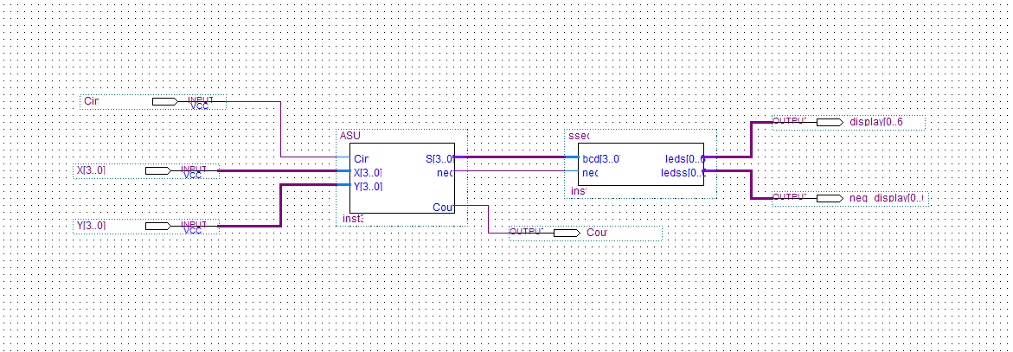
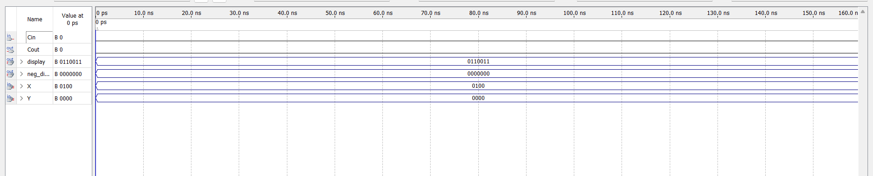
Part B
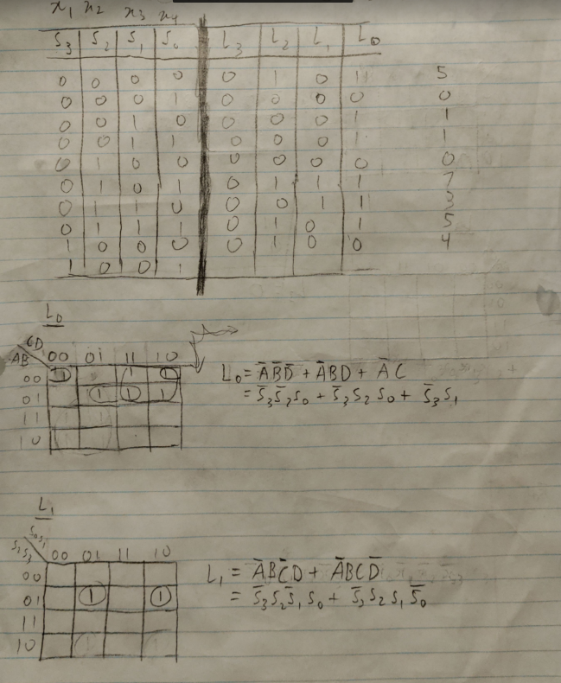
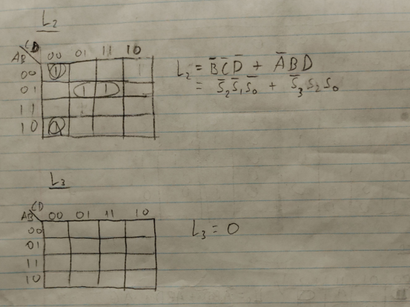
This was how I completed my table for the 4-bit student ID. K mapping was used to form an expression for my C.vhd file.
